Chapter 4, Solution 75.

For the circuit in Fig. 4.141, determine the value of R such that the maximum power delivered to the load is 3 mW.

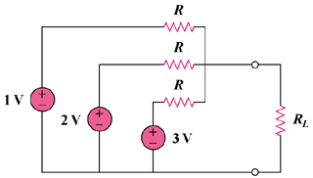

Figure 4.141
For Prob. 4.75.

Solution

We need to first find R_{Th} and V_{Th}.

v_{o}

+

V_{Th}

−

(b)

3V

+
−

R

R

R

2V

+
−

1V

+
−

R

(a)

R_{Th}

R

R

Consider the circuit in Fig. (a).

(1/R_{eq}) = (1/R) + (1/R) + (1/R) = 3/R

R_{eq} = R/3

From the circuit in Fig. (b),

((1 – v_{o})/R) + ((2 – v_{o})/R) + ((3 – v_{o})/R) = 0

v_{o} = 2 = V_{Th}

For maximum power transfer,

R_{L} = R_{Th} = R/3

P_{max} = [(V_{Th})²/(4R_{Th})] = 3 mW

R_{Th} = [(V_{Th})²/(4P_{max})] = 4/(4xP_{max}) = 1/P_{max} = R/3

R = 3/(3x10⁻³) = 1 kΩ

1 kΩ, 3 mW

